Nonagonal Antiprism
# Source: AI Source: Provided by: [Data Path: Persons Table -> ID Column: 1, Name_En Column: Motasem Essam] -> From: [ChatGPT] on [7/25/2026]
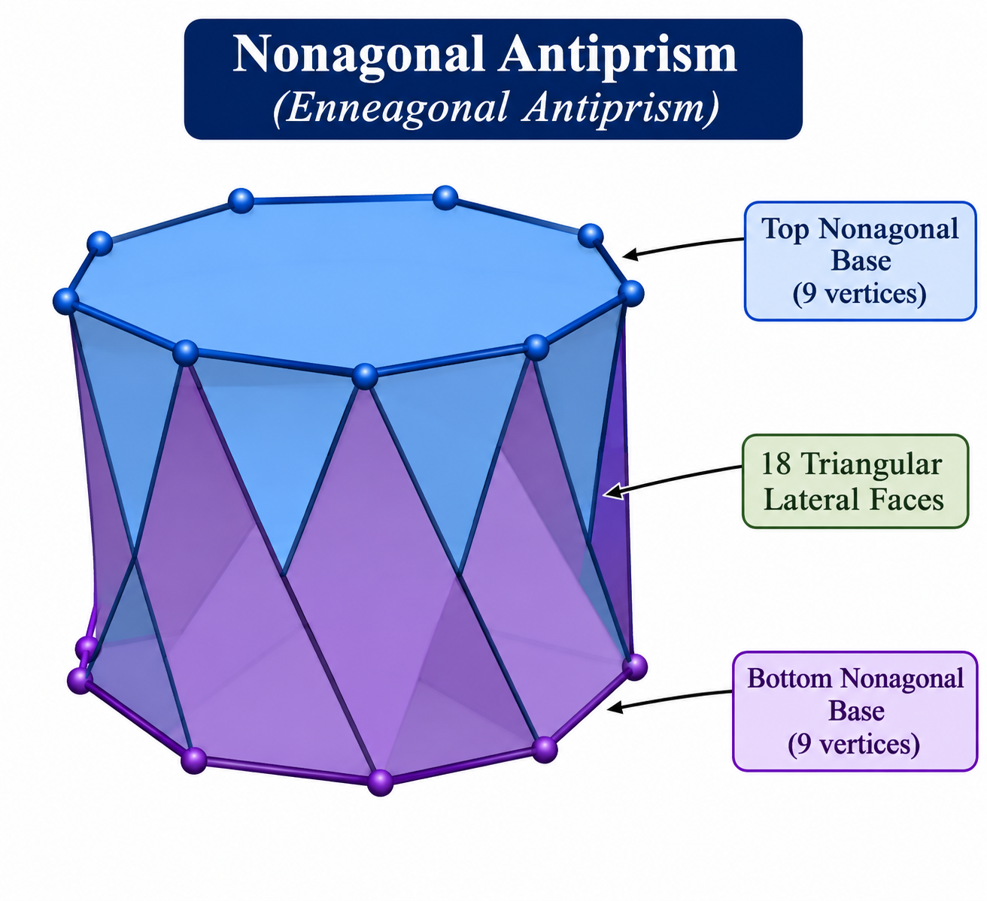

Definition
# Source: AI Source: Provided by: [Data Path: Persons Table -> ID Column: 1, Name_En Column: Motasem Essam] -> From: [ChatGPT] on [7/25/2026]
A Nonagonal Antiprism (also called an Enneagonal Antiprism) is a polyhedron consisting of two parallel, congruent nonagonal bases, with one nonagon rotated relative to the other. The bases are connected by eighteen triangular lateral faces.
It is a type of antiprism with nonagonal bases and a twisted arrangement of its lateral triangles.
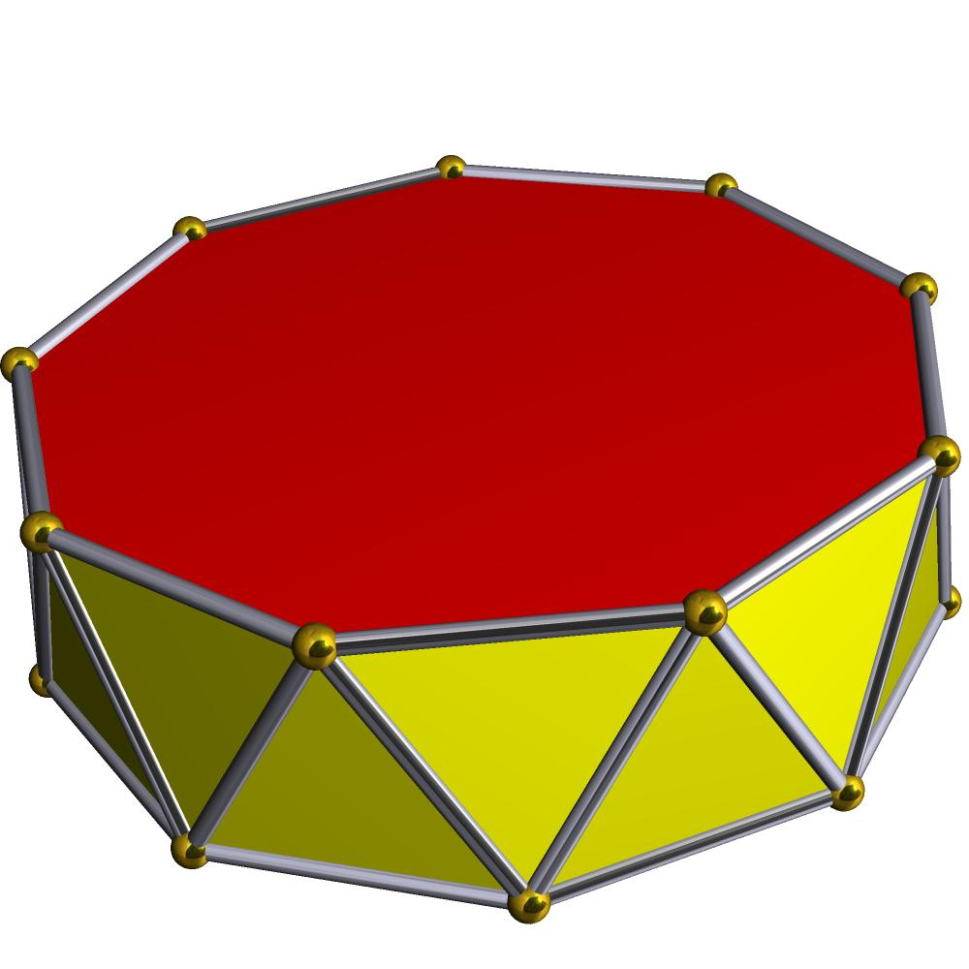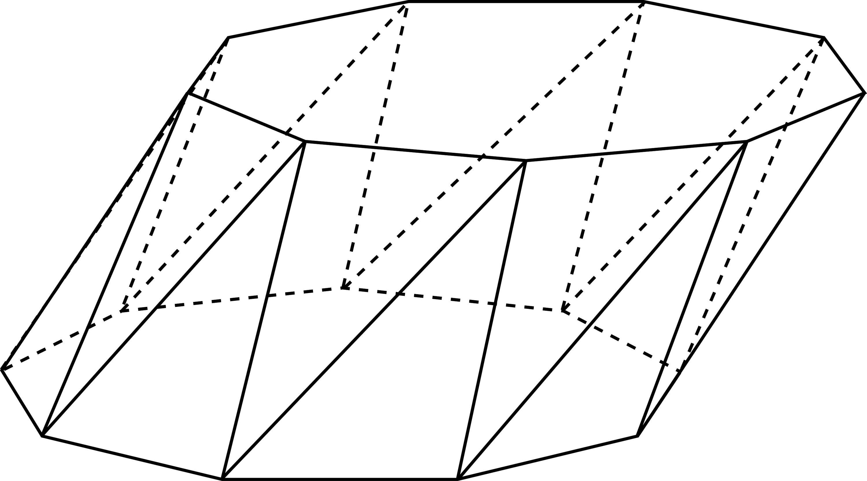

Geometric Structure
# Source: AI Source: Provided by: [Data Path: Persons Table -> ID Column: 1, Name_En Column: Motasem Essam] -> From: [ChatGPT] on [7/25/2026]
The nonagonal antiprism consists of:
- Upper Nonagonal Base: A nonagon forming the top face.
- Lower Nonagonal Base: A congruent nonagon forming the bottom face, rotated relative to the upper base.
- Triangular Lateral Faces: Eighteen triangles connecting the two nonagonal bases.
- Vertices: Eighteen vertices, with nine on each base.
- Edges: Thirty-six edges connecting the vertices.

Face Composition
# Source: AI Source: Provided by: [Data Path: Persons Table -> ID Column: 1, Name_En Column: Motasem Essam] -> From: [ChatGPT] on [7/25/2026]
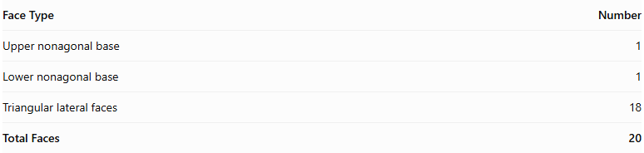
Face Type | Number
Upper nonagonal base | 1
Lower nonagonal base | 1
Triangular lateral faces | 18
Total Faces | 20

Mathematical Properties
# Source: AI Source: Provided by: [Data Path: Persons Table -> ID Column: 1, Name_En Column: Motasem Essam] -> From: [ChatGPT] on [7/25/2026]
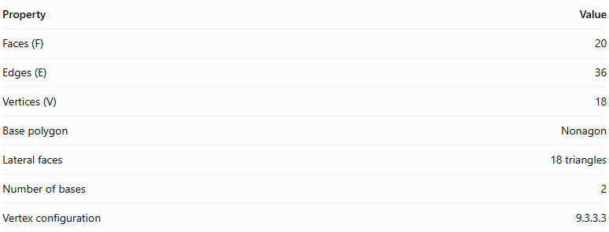
Property | Value
Faces (F) | 20
Edges (E) | 36
Vertices (V) | 18
Base polygon | Nonagon
Lateral faces | 18 triangles
Number of bases | 2
Vertex configuration | 9.3.3.3
Euler's formula:
$$V-E+F=2$$
$$18-36+20=2$$
Regular Nonagonal Antiprism
In a regular nonagonal antiprism:
- Both nonagonal bases are regular and congruent.
- The upper and lower bases are rotated relative to each other, typically by ${20}^{∘}$.
- The eighteen lateral triangular faces are equilateral.
- The vertices have the same local arrangement.

Constructing Nonagonal Antiprism in Solid Geometry

Geometric Instruments Used
# Source: AI Source: Provided by: [Data Path: Persons Table -> ID Column: 1, Name_En Column: Motasem Essam] -> From: [ChatGPT] on [7/25/2026]
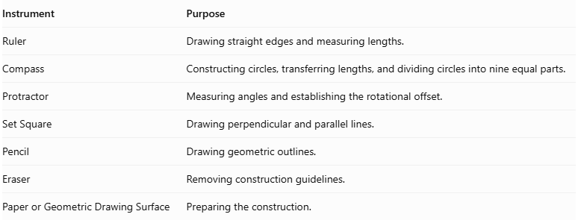
Instrument | Purpose
Ruler | Drawing straight edges and measuring lengths.
Compass | Constructing circles, transferring lengths, and dividing circles into nine equal parts.
Protractor | Measuring angles and establishing the rotational offset.
Set Square | Drawing perpendicular and parallel lines.
Pencil | Drawing geometric outlines.
Eraser | Removing construction guidelines.
Paper or Geometric Drawing Surface | Preparing the construction.

Instrument-Based Construction Procedures
# Source: AI Source: Provided by: [Data Path: Persons Table -> ID Column: 1, Name_En Column: Motasem Essam] -> From: [ChatGPT] on [7/25/2026]
The nonagonal antiprism can be constructed using geometric instruments and classical geometric drawing techniques, without using coordinate-based construction.

Constructing the Lower Nonagonal Base
# Source: AI Source: Provided by: [Data Path: Persons Table -> ID Column: 1, Name_En Column: Motasem Essam] -> From: [ChatGPT] on [7/25/2026]
- Draw a circle using a compass.
- Divide the circle into nine equal angular sections.
- Each central angle measures:
$$\frac{{360}^{∘}}{9}=\boxed{{40}^{∘}}$$
- Mark the nine vertices on the circumference.
- Connect consecutive vertices using a ruler to form a regular nonagon.
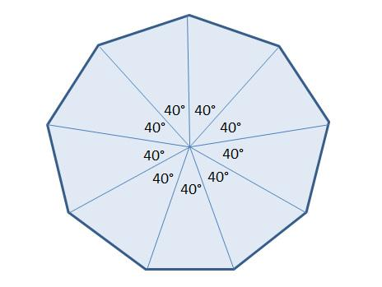

Constructing the Upper Nonagonal Base
# Source: AI Source: Provided by: [Data Path: Persons Table -> ID Column: 1, Name_En Column: Motasem Essam] -> From: [ChatGPT] on [7/25/2026]
- Draw a second regular nonagon congruent to the lower base.
- Position it above and parallel to the lower nonagon.
- Rotate its orientation by half the central angle:
$$\frac{{40}^{∘}}{2}=\boxed{{20}^{∘}}$$
- Maintain the same side length and geometric proportions.

Connecting the Two Bases
# Source: AI Source: Provided by: [Data Path: Persons Table -> ID Column: 1, Name_En Column: Motasem Essam] -> From: [ChatGPT] on [7/25/2026]
- Connect each vertex of the lower nonagon to the two nearest vertices of the upper nonagon.
- Repeat the connections around the entire solid.
- Ensure the connecting edges alternate between the upper and lower bases.
- Form eighteen triangular lateral faces.
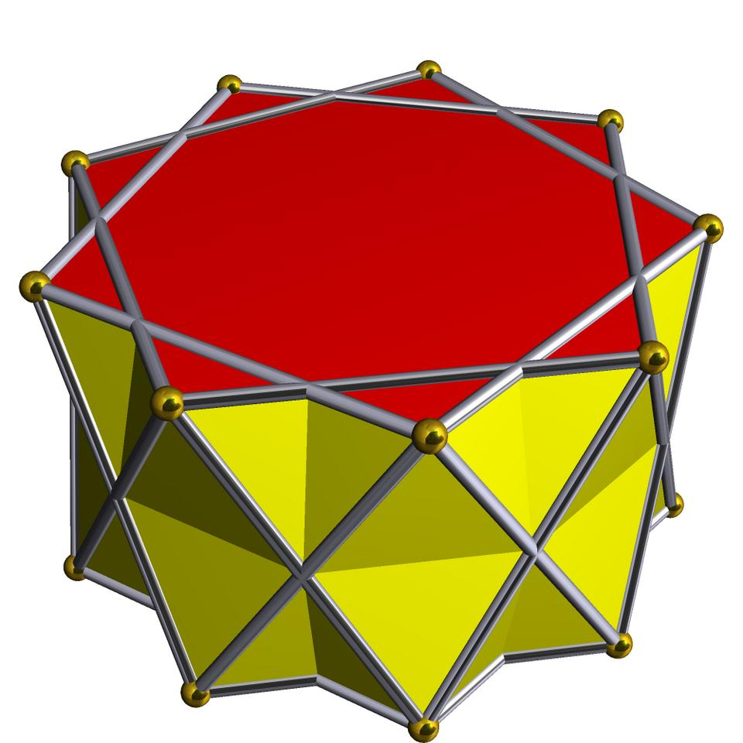

Completing the Solid
# Source: AI Source: Provided by: [Data Path: Persons Table -> ID Column: 1, Name_En Column: Motasem Essam] -> From: [ChatGPT] on [7/25/2026]
- Complete all eighteen triangular lateral faces.
- Emphasize the visible edges.
- Use dashed lines for hidden edges when necessary.
- Verify that both nonagonal bases are congruent and parallel.
- Check that the upper base has the correct 20° rotational offset.

Constructing a Net
# Source: AI Source: Provided by: [Data Path: Persons Table -> ID Column: 1, Name_En Column: Motasem Essam] -> From: [ChatGPT] on [7/25/2026]
A net of a nonagonal antiprism contains:
- Two congruent nonagonal bases.
- Eighteen triangular lateral faces.
- A connected arrangement of faces with matching edge lengths and correct face adjacency.
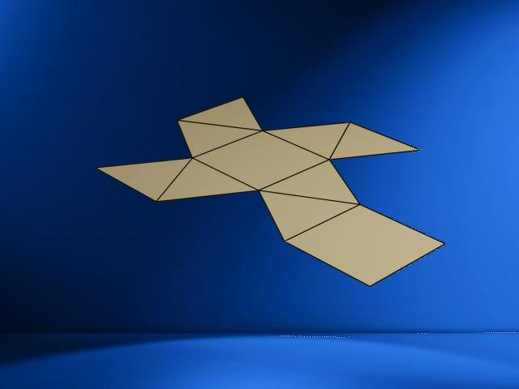

Key Points
# Source: AI Source: Provided by: [Data Path: Persons Table -> ID Column: 1, Name_En Column: Motasem Essam] -> From: [ChatGPT] on [7/25/2026]
- It has two parallel nonagonal bases.
- The bases are rotated relative to each other.
- It has eighteen triangular lateral faces.
- It contains 20 faces, 36 edges, and 18 vertices.
- Its regular form is a uniform polyhedron.

Classification
# Source: AI Source: Provided by: [Data Path: Persons Table -> ID Column: 1, Name_En Column: Motasem Essam] -> From: [ChatGPT] on [7/25/2026]
Solid Geometry
└── Types of Solids
└── Antiprism
└── Types of Antiprisms
└── Nonagonal Antiprism
├── Upper Nonagonal Base
├── Lower Nonagonal Base
└── Triangular Lateral Faces

Conclusion
# Source: AI Source: Provided by: [Data Path: Persons Table -> ID Column: 1, Name_En Column: Motasem Essam] -> From: [ChatGPT] on [7/25/2026]
A Nonagonal Antiprism is an antiprism with two congruent nonagonal bases and eighteen triangular lateral faces, arranged in a twisted configuration.

